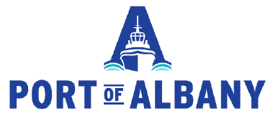

Port of Albany, NY submission for AAPA 2018 Communications Awards Program
Annual Report Category

The Port of Albany is submitting its Annual Report /Year in Review for the 2018 AAPA Communications Award Program. The report is the Port of Albany’s primary marketing piece used to represent the Port of Albany, its operations, accomplishments and goals and initiatives for the future. This report is a pivotal piece of marketing for our organization that has less than $300,000 in marketing budget. This report was the Port’s biggest report ever produced. It was the largest, as a spiral bound report and most pages. This was due to wanting to represent all the big things that the Port of Albany is currently undertaking. This includes administering a recently awarded federal TIGER grant and two New York State economic development funds to implement a major overall Big Lift Maritime Infrastructure Investment Plan. Port leadership took enormous time and effort to adequately document the activities and updates to promote and represent the Port of Albany and show the local, state and federal community the benefits and outcomes. We have received extremely positive feedback from partners, consultants, engineers, public officials, leaders and others.

- What are/were the entry’s specific communications challenges or opportunities?
What are/were the entry’s specific communications challenges or opportunities?
Describe in specific and measurable terms the situation leading up to creation of this entry.
Briefly analyze the major internal and external factors that need to be addressed.

Each year the Port prepares an annual report. Practically, this report was the largest and lengthiest document to date. The goal was not to overdo it or the flood the reader with information. But the goal was to represent the activities and initiatives going on at the Port adequately and do it in map, chart, text and graphic form to have a dynamic interaction with the reader. It was important to show the world map to represent how expansive the Port of Albany’s transportation network connection is for our customers. It was important to spotlight the construction projects and give depth to what the purpose is and the need for investment. The depth and breadth of this report achieved this level of communication to broad range of audiences.

The timing of this report followed the Port’s federal TIGER award for almost $18 million and a component of a nearly $50 million maritime investment program. This was a critical factor in the design and presentation of the report, to substantially cover the plans and strategies involved. This report was ultimately used to represent the Port of Albany in appreciation and justification of a few successful state and federal grant endeavors. The report was a critical piece for many dynamic uses for the Port during an active period in the Port’s history.

The report needed to present all of this information in an exciting and consumable way in order to serve an average reader – as well as potential customers and partners. The goal was to report in an informative and exciting manner that would attract and keep interest and show the increasing capacity and growth. It also intended to represent meaningful background for the Port of Albany’s growing reputation for handling big lift and project cargo.

- How does the communication used in this entry complement the organization’s overall mission?
Explain the organization’s overall mission and how it influenced creation of this entry.

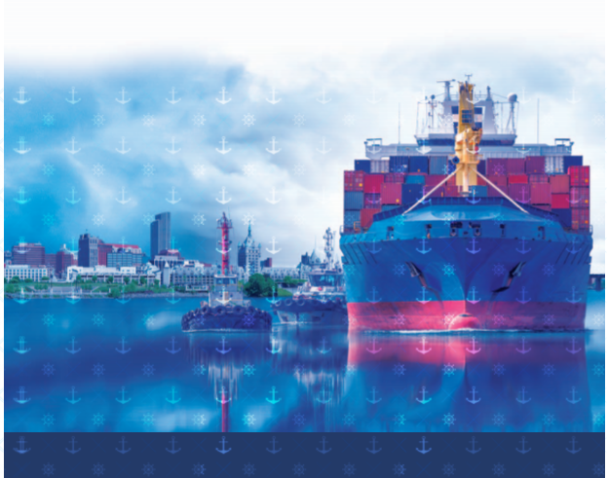
The Port of Albany’s mission is focused on responsibly and effectively managing the publicly-owned maritime Port of Albany-Rensselaer, contributing to the economy of Capital Region in New York State and beyond while emphasizing transparency, public stewardship, Integrity, Professionalism and Customer Service. This mission is weaved into how the information is presented and how the report includes details of investments, economic indicators of the port, for better and for worse and what is ahead for the Port based on careful planning and leadership. This year the Port specifically included its mission, performance measures and values statement. This was new and was well received by readers that provided feedback that this was interesting or gave confidence in doing business with the Port of Albany. A few exciting components in this year’s report were the highlight on the General Manager and linking to a video on the Port’s website, the spotlights on the two big construction projects underway and a fold out map detailing specific export and import locations the Port of Albany did business with around the world in the past year. Additionally exciting, was the cover chosen for the year in which so many big construction projects were kicked off. The cover took an aspirational approach, placing a container ship on the cover. These ships don’t call on the Port of Albany but the idea was to give a sense of exploring what is possible, looking toward the future. This report took an enormous amount of time in research, outreach and design. The report included tenant news and highlights, reinforcing partnerships and district-wide activity.

- What were the communications planning and programming components used for this entry?
Describe the entry’s goals or desired results.
Describe the entry’s objectives and list specific, measurable milestones needed to reach its goals.
Identify the entry’s primary and secondary audiences in order of importance.

The goal was to produce a report that would serve a few different readerships and relay the exciting, positive and in some cases unprecedented things happening at the Port of Albany. The readership this was aiming for includes local and regional public officials, leaders and community partners as well as to communicate to industry partners, customers and potential customers. In terms of local readership it was intended to relay the scale of activity, operations and impact at the Port of Albany specifically in light of recent major maritime infrastructure investments. In terms of industry and customer readers it was intended to relay capacity and the opportunities available as well as plans for future growth and added capacity. The Port team wanted to reach the regional partners and relay the exciting events, and show return on investments that have been supported by state partners. The Port measured this by increased call for tours and meetings, and by continued support with funding requests and inclusion in regional strategic planning efforts. The Port also sought to have the report help with new customers and new partners. The team had a goal of utilizing the majority of the reports printed as well as providing the report on line via the website and in email format. The Port team also sought to have the report incorporated into new and fresh branding for the Port and it has. Our new consultants and new engineering partners recognize this. The primary audience is regional marketplace and new customers, and the secondary is new regional contacts and new relationships.

- What actions were taken and what communication outputs were employed in this entry?
Explain what strategies were developed to achieve success and why these strategies were chosen.
Specify the tactics used (i.e., actions used to carry out your strategies).
Detail the entry’s implementation plan by including timeline, staffing and outsourcing used.

The report was released at the Port Industry Day, over 200 reports were provided. Port Industry Day occurred in June where the keynote speaker was Lauren Brand from MARAD as well as Jonathan Daniels from the Port of Gulfport. Both spoke about the impact of federal investments on ports and expanding capacity and customers. There was tremendous interest in the speakers content and feedback received was extremely positive.
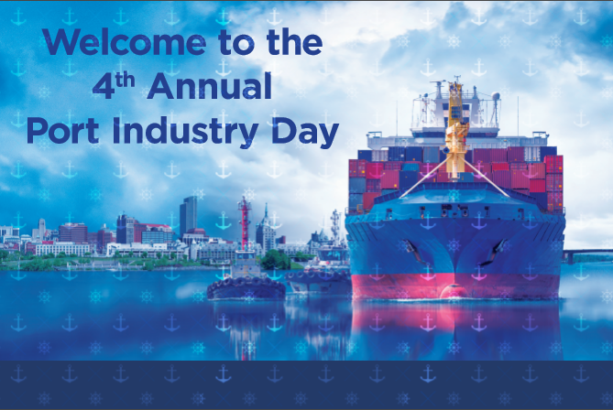
Port Industry Day is still relatively new for the Port of Albany and is modeled after larger Port events, with the goal of welcoming community members, elected officials, businesses and customers.
The report was also directly mailed to over 250 regional partners, it was used in every port tour, often 20-50 copies at a time and was included in every single new customer and new partner meeting and used in business development conferences and meetings. The report was also used to rebrand the Port’s powerpoint presentations – to reinforce branding of what the Port was representing – new projects, record setting business, big investments!

The timing of the report was focused on representing the events of the year and timing to be produced and first available in time for the Port’s largest public event in June – Port Industry Day. The report is produced with one single point of contact on the Port of Albany team who consults with the General Manager, the business development manager, the financial team and coordinates with a professional graphic design team to produce the report.
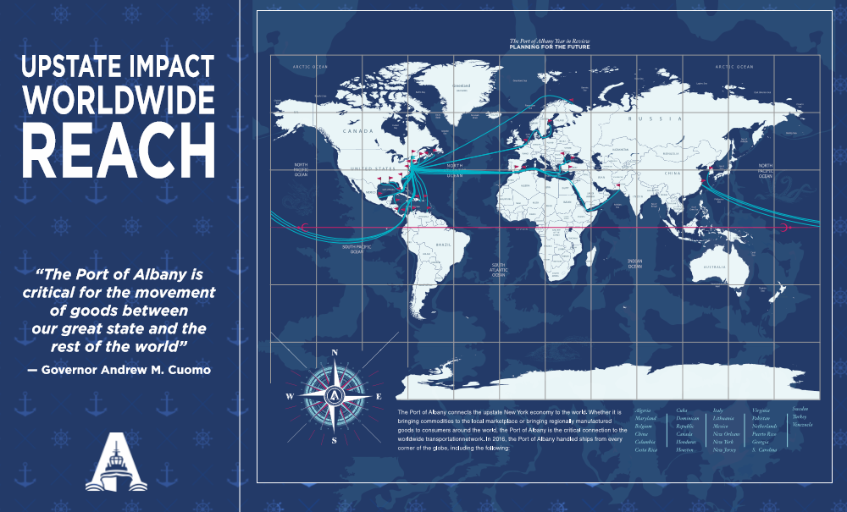
The report relied on statistics and trends to represent activities at the Port of Albany and inform the reader. This is an overview of business growth and the highlights on economic indicators the Port tracks. A critical component of the mission of the Port is to develop and safeguard commerce. This is important to represent in an interesting and informative way. It helps to show our partners and sponsors the positive return on investments and also shows potential partners and customers the healthy business climate that is available at the Port of Albany.

- What were the communications outcomes from this entry and what evaluation methods were used to assess them?
Describe any formal/ informal surveys used, or anecdotal audience feedback received, that helped in evaluating the success of this entry.
If possible, explain how this entry influenced target audience opinions, behaviors, attitudes or actions.

This year’s report was certainly the biggest undertaking in terms of time, effort and size of an annual report for the Port of Albany. The port administration team is a relatively lean staff so to dedicate the time and attention to produce such a full product is a testament to the importance of the report in communicating the operations and activities at the Port of Albany. The result was an extremely comprehensive and information packed report.

This year’s report was unique in that it coincided with the Port winning a federal MARAD TIGER award as well as two state economic development funds and with the Port of Albany undertaking an expansion initiative that would add 25% land size. 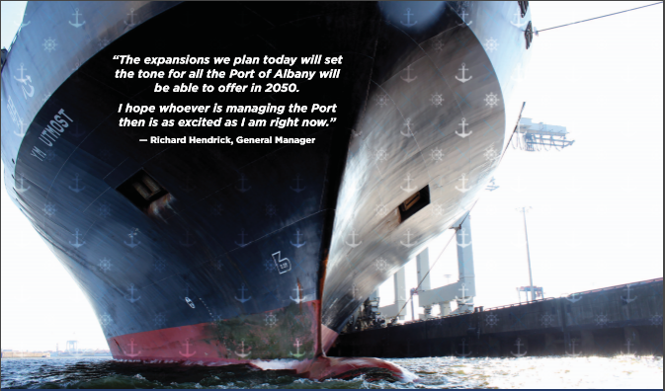

The Port used this report in every marketing and customer relation meeting. Feedback has ranged from statements like “this is beautiful” and “I love to see what the Port is doing” and “This report is so interesting” and “who designed your report – can you assist our organization”.

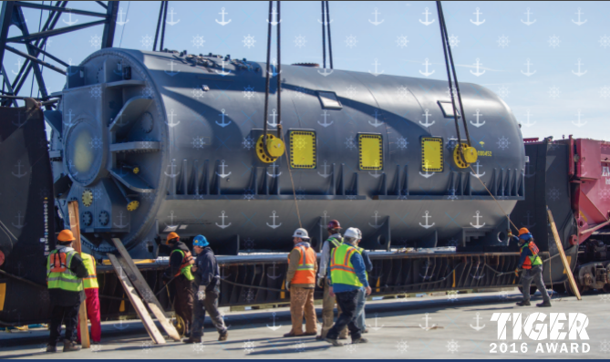
The report was used as follow up and reporting on two successful state and federal grant awards during the year. These grants were both extremely competitive and will support efforts to expand the port’s capacity in heavy lift handling capacity as well as expand the Port’s footprint. The successful grants include a $5 million New York State economic development infrastructure award and a $17.8 million federal TIGER award. We believe having a substantial report out on what is to be accomplished and when and why utilizing the annual report is critical as a public port.

All in all, over the period of a year of using the report we have received extremely positive feedback from all avenues – including from the City of Albany Economic Development team, from tenants of the Port, from regional economic development partners, and from consultants from around the Country. The Port leadership has been very proud of this feedback.

